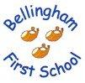 Our ‘Visual Mission’ Tree 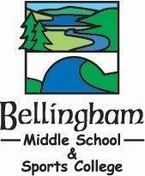

Pupils from both schools helped to create this visionary tree, working together to create our shared ethos.
- The leaves represent the pupils in both our schools
- The trunk and branches represent the adults who care and support us.
- Cherries show us the good times
- The globe demonstrates our multi-cultural awareness.
- Our subjects are represented around the tree.
- Birds represent visitors to our schools – we welcome them all.
- Flowers show our blossoming knowledge and skills.
- The sun and rain represent guidance and growth.

Our aims and ethos complement fundamental British Values of democracy, the rule of law, individual liberty and mutual respect and tolerance for those with different faiths and beliefs.

