

# Newsletter

**Monday 15th November 2021**

bs00057_

|  |  |  |
| --- | --- | --- |
|  | ***Pupils Involved*** | ***Event*** |
| **Monday 15th November** | **Maths week!** | |
| **Tuesday 16th November** | **Whole school**  **Reception** | **PE (come in PE kit)**  **Tree-mendous Forest School session (outdoor gear needed!)** |
| **Wednesday 17th November** |  |  |
| **Thursday 18th November** | **Class 2** | **Swimming - need swimming kit (costume /trunks, goggles and a towel in a bag)** |
| **Friday 19th November** | **Whole school**  **Reception** | **Nasal Flu vaccinations**  **Forest School session**  **‘Friends’ (PTA) meeting : Fountain Tea Rooms** |
| **Monday 22nd November** |  |  |
| **Tuesday 23rd November** | **Whole school**  **Reception** | **PE**  **Tree-mendous Tuesday (Forest school)** |
| **Wednesday 24th November** |  |  |
| **Thursday 25th November** | **Class 2** | **Swimming - need swimming kit (costume /trunks, goggles and a towel in a bag)** |
| **Friday 26th November** | **Reception** | **Forest School** |

*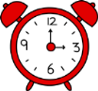Please contact our school office as soon as possible if your child is absent – thank you.*

***For the safety of all children - please inform school directly if there are any changes to your child’s home time arrangements – thankyou.***

***If your child has any COVID-19 symptoms you will be asked to get them tested with a PCR test following the latest government guidance.***

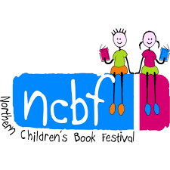 Ross Collins ‘Visit’

Class 1 and 2 had a lovely morning taking part in this digital event. Everyone enjoyed sharing his stories and learning how to do some book illustrations.

It may be that we have some budding authors amongst us!

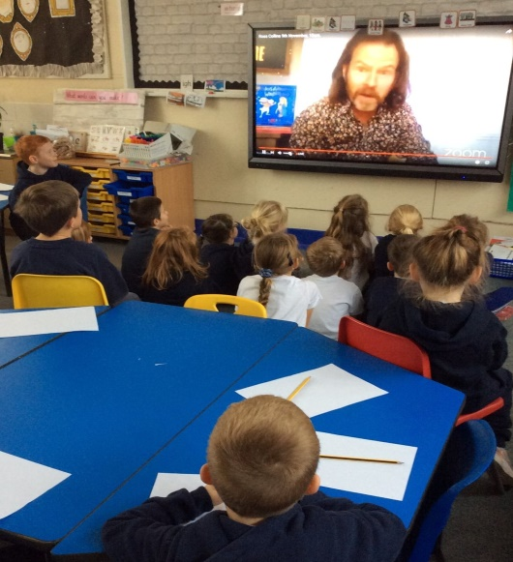 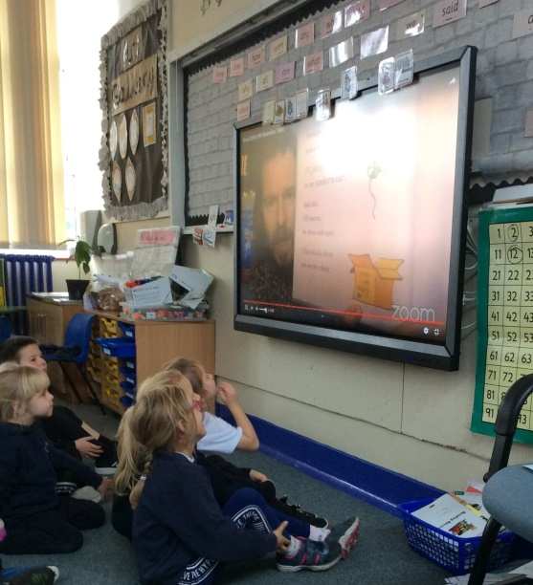

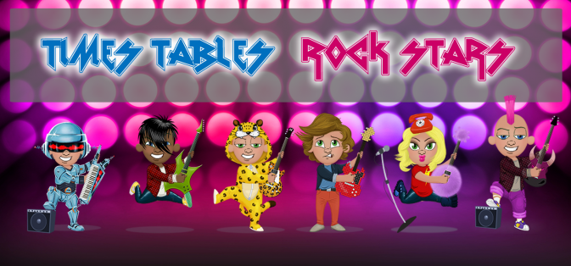

Class 2 are LOVING their Times Tables Rock Stars and have spent lots of time on it at the weekend.

Well done!

Spring Term Milk orders – please use your ParentPay account to confirm your order. Thank you.

What are we doing in our classrooms this week…?

**Reception Topic** – Snap, Crackle, Pop. **Book of the week**-  "Owl Babies" by Martin Waddell

**Communication and Language**- We will begin to listen to our new focus story and begin to become familiar with the story.

**Personal and Social Development**-We will talk about how the owls in the story are feeling and if we have ever felt the same.

**Physical Development** – In PE, we will continue to take part in a range of PE activities with Mr.Ellison.

**Literacy**- We will be helping the owl babies in our story to read and write simple words. .Following our Read, Write Inc phonics programme we will be learning the letter sounds e, l and h.

**Mathematics**- We will be focusing on the numbers 1 to 6  and how we can make these amounts.

**Understanding the World** – We will be exploring the dark both inside and outside and describing what we can see, hear and feel.

**Expressive Arts and Design** – We will draw night time woodland pictures using charcoal and will write and perform our own poem about how we feel in the woods at night. We will continue with our music session with Mr Burns.

Class 1:

English- Our core book this half term is 'The Bluebird and the Robot''. This week we will be continuing  learning about conjunctions (and, but, so, or). We will be researching blue to help us to write a non- chronological report.

Maths- Our topic is addition and subtraction.  Year 1 will be learning about fact files using addition and subtraction sentences.   Year 2 will be learning how to use lots of different methods to solve subtraction sentences such as column addition, using a number line.

Science- Our topic this half term is materials.  This week Year 2 will be identifying man made and natural materials and sorting materials.  Year 1 will be sorting materials into materials into different groups.

History- Our topic this half term is 'The Great Fire of London'. This week we will be learning about the events of 'The Great Fire of London' and sequencing them.

Design & Technology- Our topic this half term is designing and making a fire engine.  This week we will be exploring wheels and axles to help us to create the fire engine.

P.E- Mr Ellison will be doing games this half term with a focus on multi skills and games.

R.E- This half term we will be learning about how christians celebrate  christmas.  This week we will be discussing what festivals we celebrate.

Computing- This half term we will be learning about coding.  We will be using the app scratch jr and exploring it this week.

P.S.H.E- This week we will be continuing to  learn about how to have a growth mindset and how we can have a growth mindset in class.

Music- Mr Burns will be teaching us lots of new songs and teaching us how we can use our bodies as instruments.

How to help at home- Can you identify characters in the story and describe them?

**Class 2:**

**English** - We continue Leon and the Place Between this week by predicting what will happen next in the story and what the next act will be. We are going to be creating adverts to persuade people to come to the show. When Leon has to decide whether to 'step into the magic', we are going to be writing letters of advice to him. We will then finish the week by creating our own stories of what happens through the unopened doorways. Year 5 will also be finishing their work on relative pronouns.

**Maths** -

    Year 3 - This week Year 3 will be continuing their work on times tables by learning to multiply and divide by 8. We will then spend the rest of the week consolidating our 3, 4 and 8 times tables that we have learned.

   Year 4 - We are going to be learning our 7 times tables this week and ensuring that we can multiply and divide by 7. We will then be moving on to multiplying and dividing by 10 and 100.

   Year 5 - This week we are going to be working on prime, square and cube numbers before doing some work on inverse operations.

We are then all going to end the week with some problem solving.

**Science** - Year 3 and 4 will be looking at night and day, we will be learning about the Earth rotating and how the sunlight creates light. We will be exploring how different countries have different time zones because of this. Year 5 will be continuing their work on reflection and refraction, they will be investigating items that refract light.

**Topic** - This week we are learning about what life was like before the Vikings.

**RE** - We are going to be creating storyboards about the journey to Bethlehem.

**French** - This week we are going to be learning how to talk about our homes in French.

**DT** - We will be creating our Viking shields this week - we would really appreciate any spare cardboard that you might have at home!

**PSHE** - We will be working on finding solutions to disagreements this week.

**PE** - Multi-skills with Mr Ellison and swimming on Thursday.

Helping at home - Times Table Rockstars passwords have been sent out and we all really enjoyed using this last week in school. Please use this resource at home to improve our times tables recall.

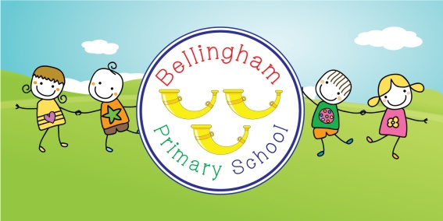 School admissions

The on-line portal is now open for school admission to Reception for September 2022.

The following link should take you to the page needed to apply for your place.

<https://www.northumberland.gov.uk/Education/Schools/School-admissions-places-appeals-1/Reception-entry-applications.aspx>

Our ever- supportive group of parents are getting organised for Christmas and would like your support in creating a super-raffle. The ‘Friends’ will gratefully accept all donations into school from now- thank you in advance.

The next Friends meeting will take place on Friday 19th November and will be kindly hosted by the Fountain Tea Rooms after drop-off in the morning.

**Additional COVID-19 control measures in schools.**

Please bear with us as we implement the advice and seek further guidance on specific events.

With identified positive cases in school we continue to be vigilant with our hand sanitizing but aim to keep working as a whole school ‘bubble’ allowing our children to be together and support their wellbeing.

We appreciate your continued support in keeping our communities and families safe.

**Advance dates for your diaries – as the weeks whizz by we know some advance notice is always helpful ( but we try not to bombard you!)**

19th November – nasal flu vaccinations

2nd December – Christmas Bingo for children (after school)

7th December – Christmas cinema night for children (after school)

10th December – Christmas performance - this is currently under review and may be a filmed performance rather than a public one.

Obviously these are all dependent on COVID restrictions but we’re hopeful in our plans.