Vision Statement for Design and Technology – Bellingham Primary School

At Bellingham Primary, we are designers and technologists. We want our children to love Design and Technology. We want them to have no limits to what their ambitions are and grow up wanting to be architects, graphic designers, chefs or carpenters. It is our intention that our D&T curriculum will provide opportunities to solve real and relevant problems, allowing our pupils to develop essential everyday skills and unlock their potential to be the designers and innovators of tomorrow. The D&T curriculum will encourage children to learn, think and intervene creatively to solve problems both as an individual and as part of a team. Design and Technology will allow all Bellingham pupils to put their learning from other areas of the curriculum into practice and will work to enhance and deepen their understanding of those areas, including Maths, Computing, Science, and Art. Bellingham pupils will learn about cooking, food and nutrition, ensuring that they acquire the fundamental life skills in order to be able to feed themselves healthily and independently, whilst learning about where food comes from, therefore making connections with their geographical and scientific knowledge. We want to equip them with not only the minimum statutory requirements of the Design and Technology National Curriculum but to prepare them for the opportunities, responsibilities and experiences of later life.

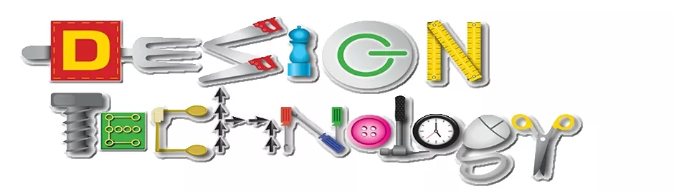

Curriculum Implementation
To ensure we meet the intended aims of the national curriculum, 4 main themes are covered throughout KS1 and KS2 including construction, mechanisms, textiles and food and nutrition. When designing our curriculum within these themes, we have focused on 5 main areas:
- Knowledge of an inventor/designer/culinarian: what did they create, why did they create it and how can this influence our own work?
- Plan: using the influence of the inventor/designer/culinarian what skills have they learnt which can help us plan a final piece?
- Make: creating their final piece using their knowledge. How have they developed their skills?
- Evaluate: can they evaluate their work? How could they improve it? What do they feel has been successful? Technical knowledge: can they use subject specific vocabulary to discuss their product and how it works, tastes or looks?
DT at school provides challenging and enjoyable learning through a range of experiences where the children are exposed to rich learning experiences. Teachers will use a progression of skills document which show how the children’s skills in each area are developed throughout KS1 and KS2. Children evaluate their own work and others work at the end of each unit. Success in DT is acknowledged and celebrated through displays in classrooms and around school. An emphasis on working in an inclusive environment is pivotal for all children to be able to access the curriculum. All children are given the opportunities to challenge themselves through both independent and supported learning activities.

Early Years
Through Expressive Arts children are encouraged to construct and create purposefully selecting tools and techniques needed to shape, assemble and join materials they are using. children learn through first-hand experiences which involve putting their ideas into practice to develop an awareness and understanding of the possibilities and limitations of different materials. Practitioners encourage children to explore, observe, solve problems, think critically, make decisions and talk about why they have made their decisions as they design and create. Children’s natural creativity is fostered and opportunities for investigation, designing and making are offered daily within our provision, which enables children to learn a great deal about their world.

Impact
The impact of our Design and Technology curriculum is in the development of our pupils being able to approach problems creatively and in a range of ways, applying their knowledge from across the curriculum areas independently. By providing a range of contexts and the necessary skills, we endeavour to support pupils in their future educational journey and in the understanding of the ever-developing world around them. The skills and attributes they develop will benefit them beyond school and into adulthood: the ability to use time efficiently, work with others productively, show initiative, independence, resilience and manage risks effectively will ensure well-rounded citizens who will make a difference in the wider world. Through the use of a termly assessment tracker and data analysis, we ensure that children who are achieving well, as well as those who are in need of additional support, are identified, and additional provision and strategies are planned in and discussed with class teachers.

