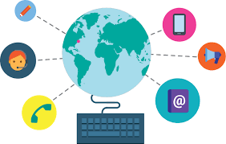
An insight into Computing within the Early Years at Bellingham
How does Computing link to the Early Years Foundation Stage Profile?
Communication and Language
Listening, Attention and Understanding - Make comments about what they have heard and ask questions to clarify their understanding.
Speaking - Offer explanations for why things might happen
What does Computing look like within the Early Years classroom?
These are some of the things you might see which link to Computing ♥ Children exploring and playing with classroom resources such as the telephone, computer keyboard and hoover. They will recreate experiences within a role play scenario such as phoning their grandparents or ‘doing busy jobs’ on a computer. ♥ Adults supporting children in using an iPad to access age-appropriate apps. ♥ Children using iPads or cameras to take photographs. ♥ Children using programmable toys such as bee-bots independently within their play following adult-led demonstrations of how to use these types of resources.

