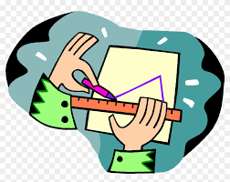
An insight into Design and Technology within the Early Years at Bellingham
How does Design and Technology link to the Early Years Foundation Stage Profile?
Expressive Arts and Design
Creating with Materials - Safely use and explore a variety of materials, tools and techniques, experimenting with colour, design, texture, form and function. • Share their creations, explaining the process they have used. • Make use of props and materials when role playing characters in narratives and stories.
Physical Development
Fine Motor Skills - Use a range of small tools, including scissors, paintbrushes and cutlery.
What does Design and Technology look like within the Early Years classroom?
These are some of the things you might see which link to DT. ♥ Children independently accessing the ‘junk modelling’ materials to create and to build. ♥ Adults demonstrating a new skill. For example, how to join two pieces of cardboard together. ♥ Children constructing and making their ideas a reality through using a variety of materials such as cardboard boxes, wooden blocks, LEGO or even playdough. ♥ Children drawing out a plan of what it is they are going to make, create or build. ♥ Children using their ‘planning time’ to verbally share their ideas for independent play. ♥ Children making healthy choices at snack time and making healthy food.

