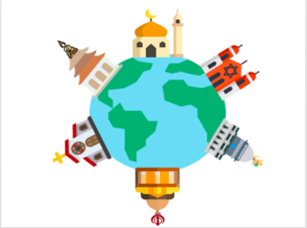
An insight into RE within the Early Years at Bellingham
How does RE link to the Early Years Foundation Stage Profile?
Understanding the World
People, Culture and Communities - Know some similarities and differences between different religious and cultural communities in this country, drawing on their experiences and what has been read in class.
What does RE look like within the Early Years classroom?
These are some of the things you might see which link to RE ♥ Children developing positive relationships with other children and with adults. ♥ Children joining in with a number of celebrations throughout the year such as Christmas, Easter, Eid and Diwali. ♥ Children independently accessing resources which link to some of the traditions surrounding a range of religions and their celebrations. ♥ Children listening to stories based around a variety of different cultures and traditions. ♥ Children participating in the Nativity performance in the Autumn term and taking part in activities which support their understanding of this Christian story.

