

# Newsletter

**Monday 13th June 2022**

bs00057_

|  |  |  |
| --- | --- | --- |
|  | *Pupils Involved* | *Event* |
| Monday 13th June | Whole school | Music with Mr Burns. |
| Tuesday 14th June | Whole school  Reception | PE (outdoor PE kit needed)  After school clubs – finish at 4pm.  Forest School session outdoors. |
| Wednesday 15th June | Year 4 | Multiplication check |
| Thursday 16th June | Reception 2022  Class 2  All of Class 1 (For this week only!) | All day in school  Quad Kids – need outdoor PE kit.  Swimming - need swimming kit (costume /trunks, goggles and a towel in a bag) |
| Friday 17th June | Reception and Class 1 : Multi-skills festival (here) PE kit needed  Class 1: Forest school session | |
| Monday 20th June | Whole school | Music with Mr Burns. |
| Tuesday 21st June | Whole school  Reception  Year 5 | PE  After school clubs – finish at 4pm.  Forest School session – outdoors.  Residential visit to Seahouses (return Thursday pm) |
| Wednesday 22nd June |  | ‘Friends of Bellingham Primary ‘ meeting -here 9am |
| Thursday 23rd June | Reception 2022  Year 2 & Class 2 | All day in school  Swimming |
| Friday 24th June |  | |

**

*Please contact our school office as soon as possible if your child is absent– thank you.*

What are we doing in our classrooms this week…?

**Reception Topic -**Oh, I do like to be beside the seaside.**Book of the week**-  Billy`s Bucket.

**Communication and Language**- We will continue to read Billy`s Bucket and we will extend our vocabulary with a focus on sea creatures.

**Personal and Social Development**- We will continue our Transition sessions in Class one.

**Physical Development** – We will focus on athletics and team games with Mr Ellison.

**Literacy**- We will write about what we think Billy will choose as a present and we will write about what we think we would see in Billy`s Bucket.We will focus on writing in short sentences with words with known letter-sound correspondences using a capital letter and full stop. We will continue to follow our Read, Write Inc phonics programme and practise reading tricky words and words with the digraphs we have learnt so far.  We will play a tricky word fishing game.

**Mathematics**- We will work on the composition of numbers to 10, with a focus on odd and even numbers.

**Understanding the World** –  We will find out about underwater animals and we will create underwater worlds in our own buckets.

**Expressive Arts and Design** – We will continue with our music session with Mr Burns. We will make representations of underwater creatures using paint, pastels and collage materials.

Class 1:

English: Our core text is 'The Lighthouse Keepers Lunch' by Ronda and David Armitage.  We will be writing a set of instructions on how to make a disgusting sandwich for the seagulls in the story.  We will be beginning to write our own stories based on 'The Lighthouse Keepers Lunch'.

Maths: Our topic is weight.  We will be exploring and weighing objects and discussing which objects are heavier and lighter.  Year 1 will be measuring objects using cubes and weighing scales.  Year 2 will be using gram and kg weight to weigh objects.

Science: Our topic is plants and using our scientific skills to investigate questions.  Our question this week is 'What does a seed need to grow?' We will be looking at how well our seeds have grown in different conditions and discussing if our predictions were correct about what a seed needs to grow.

History: Our topic this half term is 'Seaside holidays from the past'.  This week we will be using different historical sources to identify what seaside  holidays were like in the past.

Design Technology: Our topic this half term is 'Seaside collages and puppets'. This week we will be designing and making finger puppets based on our favourite story characters.

Computing: We will be learning about how to keep safe online and focusing on how to keep safe while playing games online.

P.H.S.E: Our topic this half term is changing me.  This week we will be discussing how we have changed since we were a baby and how our bodies will continue to change as we get older such as getting taller.

P.E- We will be doing team games and athletics with Mr Ellison.  Our whole class will be swimming this week as Class 2 are taking part in a sporting event in school.

How to help at home: Can your child make predictions about what could happen next in the story? This could be using their school reading book or a story book.

*What are we doing in our classrooms this week? Continued…*

Class 2 :

English - This week we are working on our reading skills before writing a script to perform in class about our story. We will then be creating storyboards to show what has happened with the Cyclops and then writing a diary entry as one of the crew members returning to Ithaca.

Maths - This week Year 3 and 4 will be continuing their work on time by using 24 hour clocks and ensuring they know the difference between am and pm. Year 3 will also be working on finding and comparing the duration of an event. Year 4 will be working on using hours, minutes and seconds as well as years, months, weeks and days. Year 5 will be continuing decimals by multiplying and dividing by 10, 100 and 1000 before moving onto learning about volume towards the end of the week.

Science - Year 3 and 4 will be learning about food pyramids and balanced meals. Year 5 are going to learn about different time zones and why different places have different time zones.

Topic - This week we are going to compare Athens and Sparta and consider which we would prefer to live in.

PSHE - We will be learning about how babies grow this week.

DT - We are going to be learning about the history of jewellery as part of our jewellery design and technology topic.

French - We are going to be ensuring that we can count up to 30 in French.

PE - Athletics with Mr Ellison.

Helping at Home - Please work on being able to tell the time at home to help our maths topic and times tables.

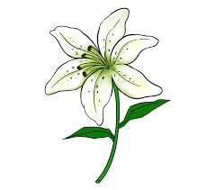Today we say’ Goodbye’ to Jesse’s dad and our school caretaker, Dave.

Mrs Goddard will attend the funeral service and Class 2 have written some messages that Jesse might read in the future, adding them to her special memory box– we’ve had a chat about all the good times and how helpful Dave was around school.

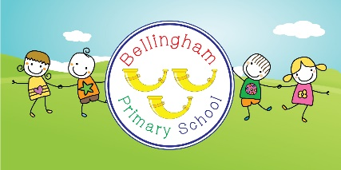Transition – a process not just a day!

We’re excited to begin our plans for our new starters and children moving classes.

Everyone had a super day last week.

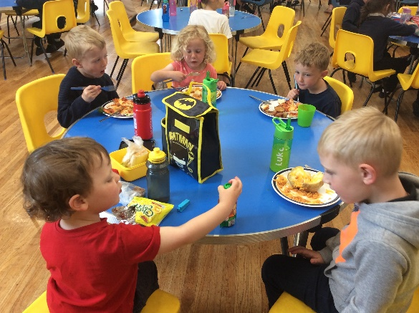 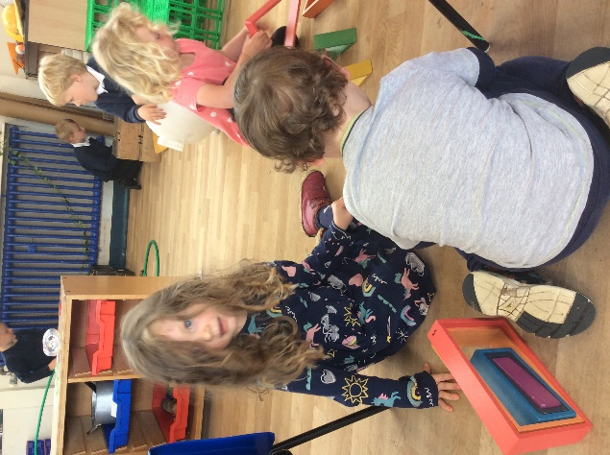

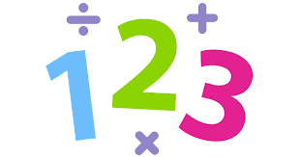Children in Year 4 will be doing the Multiplication check this week:

“The multiplication tables check (MTC) is statutory for primary schools in the 2021/22 academic year.

The purpose of the MTC is to determine whether pupils can recall their times tables fluently, which is essential for future success in mathematics.”

Our children are really good at this so we look forward to the results!