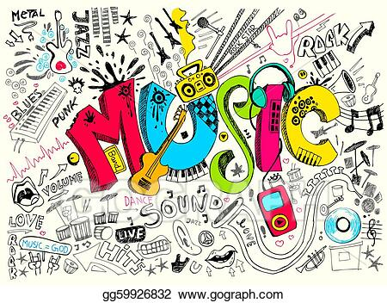
An insight into Music within the Early Years at Bellingham
How does Music link to the Early Years Foundation Stage Profile?
Expressive Arts and Design
Creating with Materials - Safely use and explore a variety of materials, tools and techniques, experimenting with colour, design, texture, form and function. • Share their creations, explaining the process they have used. • Make use of props and materials when role playing characters in narratives and stories.
Being Imaginative and Expressive - Invent, adapt and recount narratives and stories with peers and their teacher. • Sing a range of well-known nursery rhymes and songs. • Perform songs, rhymes, poems and stories with others, and (when appropriate) try to move in time with music.
How does Music look within the Early Years classroom?
These are some of the things you might see which link to Music. ♥ Children playing with and exploring the sounds of instruments which are available to them within the classroom. ♥ Children singing independently and in groups. You might see children singing or performing to an audience within the classroom environment. ♥ Children using the ‘junk modelling’ materials to create their own instruments. ♥ Adults will introduce children to a range of musical genres and works of art. Open-ended resources are available for children to recreate these things independently within their play. ♥ Adults demonstrating the addition of sound effects and a rhythmic beat when reading stories or singing nursery rhymes. e.g. ‘We’re Going on a Bear Hunt’ or ‘Three Blind Mice’. You might see children recreating this within their independent play.

