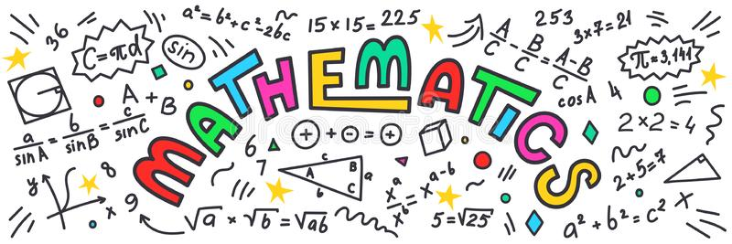
An insight into Maths within the Early Years at Bellingham
How does Maths link to the Early Years Foundation Stage Profile?
Mathematics
Number • Have a deep understanding of number to 10, including the composition of each number. • Subitise (recognise quantities without counting) up to 5. • Automatically recall (without reference to rhymes, counting or other aids) number bonds up to 5 (including subtraction facts) and some number bonds to 10, including double facts.
Numerical Patterns • Verbally count beyond 20, recognising the pattern of the counting system. • Compare quantities up to 10 in different contexts, recognising when one quantity is greater than, less than or the same as the other quantity. • Explore and represent patterns within numbers up to 10, including evens and odds, double facts and how quantities can be distributed equally
What does Maths look like within the Early Years classroom?
These are some of the things you might see which link to Maths ♥ Adult-led, discreet teaching of maths in Reception. Resources which link directly to what has been taught in these sessions are available for children to use independently within the classroom. ♥ Children developing an understanding of what numbers are. For example, knowing the ‘oneness of one’, that a single object represents one. ♥ Children exploring shape, space and measure within their independent play. This might be seen in the big blocks area where children are arranging 3D blocks and working out how shapes are used within their own environment. You might see children exploring measurement when playing in the water area, using the language of ‘full’ and ‘empty’. ♥ Adults working alongside children, demonstrating appropriate mathematical language and asking questions to move learning forward. ♥ Children engaging in play with ‘loose materials’ such as conkers, pine cones or buttons. Children make arrangements with these items and naturally count them. Adults might encourage 1:1 correspondence by showing children how to count one number name for each item they have. ♥ Children may create their own matching activities in which they place the correct number of items onto the corresponding numeral tile or card.

