Forest School 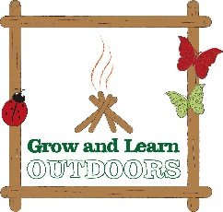
Why do we do it and what do our children learn?
Knowledge & Understanding | We live in a beautiful rural location and our children are fortunate to have a forest school area within our school grounds. Forest School helps to develop a respect for the environment and an interest in their natural surroundings, making observations into natural phenomena eg. Seasonal changes and learning to recognise different species of flora and fauna. Some of this information may be retrieved in academic attainment.
Confidence | Our children develop self -confidence and self- belief that comes from having the freedom and space to learn, grow and demonstrate their independence.
Social skills | Forest School helps to develop an awareness of the consequences of the actions on others through doing a range of activities, developing the ability to work together – sharing tools and tasks, working together to create a den or by taking part in co-operative play.
Motivation & Concentration | Children are generally keen to take part in Forest School as it involves the participation of exploratory learning and play activities as well as allowing time to focus on more concentrated tasks for longer periods of time.
Physical skills | We are able to develop children’s physical stamina and gross motor skills during Forest School sessions, moving easily around the forest site whilst also stimulating and developing fine motor skills by the effective use of tools and making structures.
Language & Communication | These well managed outdoor learning sessions inspire and stimulates conversation at all levels, prompted by the visual and other sensory experiences of a child at Forest School.
A Different Perspective | Forest School can give teachers a new perspective and understanding of the child as they observe them in a different setting. This can develop different relationships amongst all involved – seeing how they cope in different situations and dealing with new challenges. In turn this can help to evaluate the individual learning styles of our children.
Continued Learning | As a result of taking part on Forest Schools teachers can gain an opportunity to inform their own practice and may adapt their approaches to outdoor learning.  An enthusiasm for Forest School can result in changes to out-of-school routines and behaviours with families being more willing to take part in outdoor activities.

